System Sizing & Performance Tables (SSPT)

CLASSIC and PRIME series - Heating and Cooling
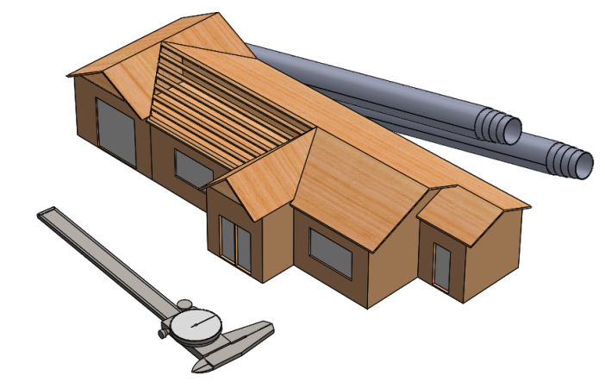

Disclaimer
This manual contains system sizing procedures and performance tables for EarthLinked® Heating and Cooling systems which may be combined with field specified, hydronic components, thermostats, water heaters, water storage tanks and associated fittings, controls and piping.
Earthlinked Technologies manufactures and sells only the EarthLinked® system components which combine to make an EarthLinked® system.
Earthlinked Technologies published performance information is based on Earthlinked Technologies supplied Products.
Therefore, Earthlinked Technologies shall not be liable for any defect, unsatisfactory performance, damage or loss, whether direct or consequential, relative to the design, manufacture, construction, application or installation of the above mentioned field specified items.

Earthlinked Technologies, Inc.
4151 S. Pipkin Road
Lakeland, Florida 33811 USA
phone: 863-701-0096 | toll-free: 866-211-6102
General Info: info-question@earthlinked.com
www.earthlinked.com
CSI # 23 80 00

TABLE OF CONTENTS
I. System Sizing Guidelines 4
1) Sizing factors 4
2) Primary requirements 6
3) Optimal system sizing and Auxiliary Heat 7
a. Optimal system mix 7
b. LoopLink 9
4) Thermostat set up 10
a. Thermostat control 10
b. Auxiliary heat set up 10
II. System Sizing Worksheets 11
A. Air Heating, 100% load 12
B. Air Cooling, 105% load 15
C. Hydronic Heating, 100% load 18
D. Hydronic Cooling, 105% load 22
III. Design Temperatures 26
ASHRAE Outdoor Design Condition 26
IV. Performance Tables 35
1) Introduction 35
2) Tutorial 36
3) Complete Performance Tables 38

System Sizing Guidelines

Please note that compressor nominal capacities are given in kBTUH and not in Tons.
This Manual describes the procedure to size an EarthLinked system. This will ensure that the house heating and cooling needs will be covered by the EarthLinked Geothermal System between the ASHRAE 99.6% heating design temperature and the 0.4% cooling design temperature.

Sizing factors
To ensure comfort and maximize economy of operation for the homeowner, EarthLinked® Systems must be sized properly for the application.
System Sizing is a function of the following 3 factors:
- Heating and Cooling Loads: The requirement to calculate the heating and cooling loads of the structure in accordance with the ACCA Manual J (latest edition) or ASHRAE procedures is absolutely necessary. Use the outdoor design temperatures listed in Section III.
- Mean Ground Temperature: The performance of the EarthLinked® System depends on the deep ground temperatures.
The deep earth temperatures for the contiguous United States and southern Canada are shown below on the map. For locations between the lines shown below: (1) ROUND DOWN to the lower temperature line for heating dominant loads and (2) ROUND UP to the higher temperature line for cooling dominant loads.
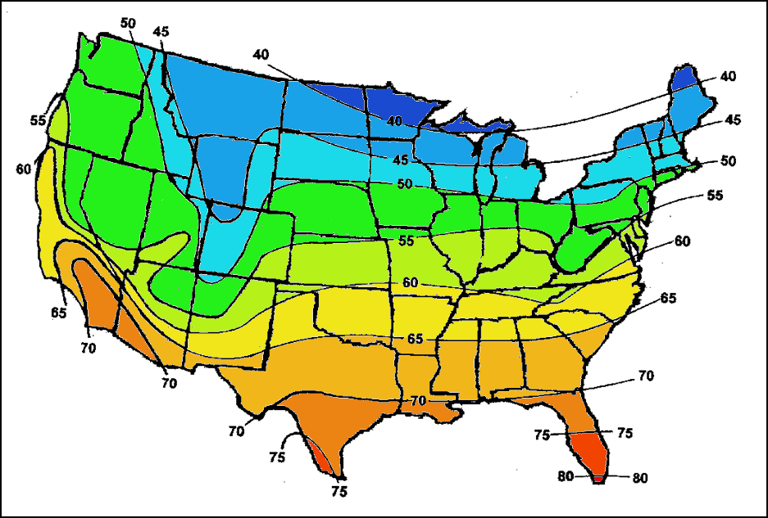
Earth Temperature in Contiguous United States and Southern Canada
- Earth Loop Configuration: The most appropriate type of earth loop for the application will be based on the local earth geology and space available for installation of the earth loop system. For specification of the most appropriate earth loop system for the application, refer to the EarthLinked® Earth Loop Manual.

Range of use of loops as a function of deep Earth Temperature

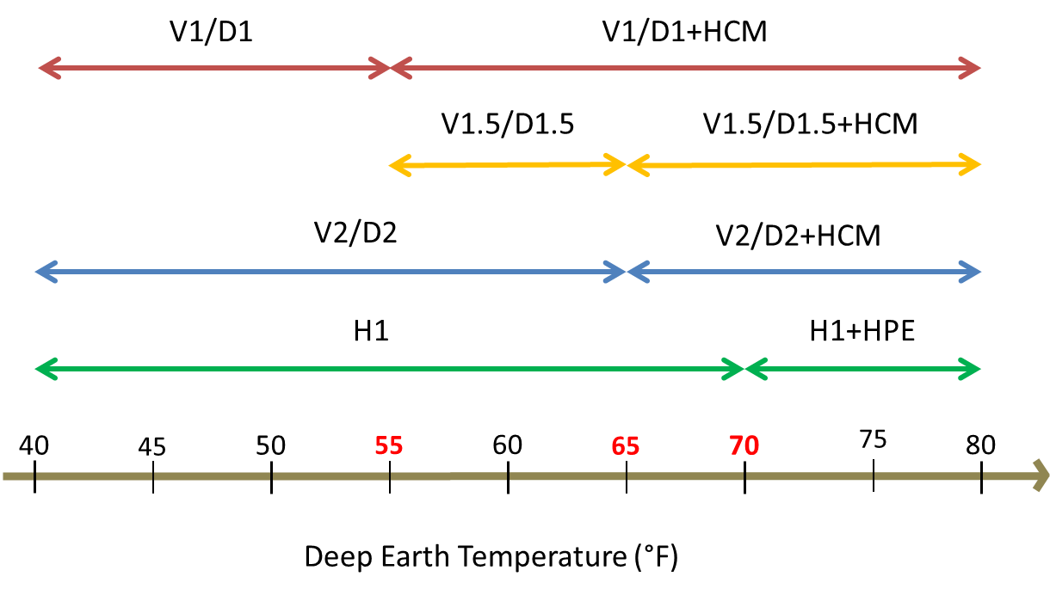

Primary requirements

Primary Requirements for Specifying an EarthLinked System

- All EarthLinked® space heating and cooling systems must be equipped with supplemental heat with a rating of at least 20% of heating load.
- EarthLinked® compressor units that provide space cooling shall be equipped with an EarthLinked® Hybrid Cooling Module (HCM) when:
  - Required by the performance tables (see Section IV)
  - or when BOTH of the following circumstances occur:
    - Ambient outdoor temperatures have exceeded the outdoor summer design temperature conditions (see Section III) for at least 7 hours of continuous system run time
    - In presence of soil with low thermal conductivity that do not effectively absorb and dissipate heat. Examples of such soils are light dry soil, dry sand, peat and organic soils, dry clay and hardpan.
No Cooling capacity or efficiency adjustments are necessary for the addition of the Hybrid Cooling Module (HCM) to the system.
- EarthLinked® compressor units that provide heating and cooling shall be factory-equipped with a Heating Performance Enhancement Kit (HPE) when required by the performance tables (see Section IV). It is recommended for any applications – especially commercial - where automatic change-over or switching between heating and cooling occurs within a 24-hour period.
- The following restrictions apply to the application of a copper earth loop system as a component of an EarthLinked® Heating and Cooling System:
  - Do not install an earth loop system in soils with high concentrations of acids, chlorides, sulfides, sulfates, carbon, coal, cinders or ammonia; or organic soils with anaerobic bacteria, or in coastal areas with brackish water marches, salt water intrusions or acidic peat bogs.
Prior to drilling or excavating for the earth loop system, it is the responsibility of the EarthLinked® system specifier to determine the presence of these noted concentrations by taking soil samples at manifold and other appropriate depths below the ground surface and at appropriate multiple locations within the intended earth loop field. Further, the soil is to be sampled, analyzed and documented by a licensed soil testing laboratory.
  - DO NOT install an earth loop system within ½ mile of a salt water sea shore or any tidal body of water.
- Do not install components or equipment with an EarthLinked® system that are not safety listed by an industry recognized safety standards agency such as UL or ETL.
- The use of non-listed or “home-made” earth loops, heat exchangers, air handlers, cased coils, etc. will jeopardize the system safety and performance and will void the warranty.
- Do not deviate from the guideline piping configurations in the appropriate EarthLinked® Quick-Start manual for the system being specified, without prior written approval from EarthLinked Technologies, Inc. Technical support at 1-863-701-0096.
- Specifications for an EarthLinked® system must adhere to the above requirements and other requirements stated in this manual. Failure to do so will result in financial consequences for the installer and will void the EarthLinked® Heat Pump HVAC Components and DIRECT AXXESS® Earth Loops Limited Warranty.

Optimal system sizing and Auxiliary Heat

Optimal system mix

EarthLinked offers the two options when designing an EarthLinked Geothermal System:
- Design the system to satisfy 100% of the Design Heating Load with geothermal heating.
- Design a system that features a mix of geothermal heating and supplemental heat to satisfy the Design Heating Load.
Therefore, when selecting an EarthLinked Geothermal System and sizing it to meet the loads of a house, one must resolve the tension between two opposing economic logic in order to choose the optimal system to install. The first logic wants to minimize the cost of operation of the system and recognizes geothermal as the most efficient solution and the cheapest to operate. The second logic wants to minimize the cost of installation of the system and resorts to auxiliary source of heat to find an optimal system mix. This second logic makes use of the fact that a geothermal system can be supplemented by an auxiliary heat source to meet the heating load. IN ANY CIRCUMSTANCES, THE SYSTEM SHOULD NEVER BE UNDERSIZED ON THE COOLING SIDE (MEANING: NEVER LESS THAN 105% OF TOTAL AND SENSIBLE COOLING LOADS).
In both scenarios one must find an economic optimum – which will differ from one project to the next - tailored to the home owner and his expressed needs. To facilitate the calculation of this economic optimum, EarthLinked has partnered with GeoConnections, Inc. to develop a customized version of LoopLink (see I.3) b.)

- 100% Geothermal System
If cost of installation isn’t an issue, EarthLinked Geothermal Heat Pumps remain the most efficient systems and an ideal solution to minimize cost of operations of the system. In this case, Auxiliary Heat will only serve as supplementary heat. Auxiliary Heat is a required component of the system.
EarthLinked requires that supplemental heat with a rating of at least 20% of the heating load, in BTUH, is installed with the system to anticipate extreme weather conditions when design temperatures may be exceeded. Auxiliary heat can also serve as emergency back-up heat.
If Auxiliary Heat is to be electrical, EarthLinked Air Handlers are shipped with a minimum Heat Strip of 5kW, which covers this 20% Auxiliary Heat requirement all the way through 60 kBTUH of nominal capacity.

$$Minimum Auxiliary Heat (kW) =\frac{Heating load \left(BTUH\right)*0.2}{3412}$$

- System Mix
If cost of installation is a problematic issue, one can resort to back-up systems for heating such as supplemental electrical heat or dual fuel. To optimize the system mix and decide what the ideal proportion of back-up heat is and determine an economic balance point, EarthLinked developed the EarthLinked Geothermal Design Software with GeoConnections, Inc. (see LoopLink see I.3) b.). This web tool will allow you to look at the operating profile of your chosen system mix and see the impact on operating costs.

CASE STUDY:
- Let’s create a project on EarthLinked’s LoopLink with the following specifications:
- Location: Charlotte, NC
- Deep Earth Temperature: 62°C
- ASHRAE 99.6% Heating Design Condition: 19 °F
- ASHRAE 0.4% Cooling Design Condition: 94 °F
- Heating Load: 39,050 BTUH
- Cooling Load: 25,500 BTUH

- We select the following system for example:
- Compressor: PSC-030 (Prime Series, 2.5 ton)
- Loop: H1
- Back-Up System: Supplemental (electric resistance)
- LoopLink shows the following system output
Heating Capacity: 29,112 BTUH Total Cooling Capacity: 38,040 BTUH
% Sizing (heating load): 75.6 % Sensible Cooling Capacity: 28,530 BTUH
% Energy from Geothermal: 98.1 % % Oversizing: 24.3 %
Building Balance Point Temperature: 25.6 °F
GSHP Heating Operating Cost: $329.29 GSHP Cooling Operating Cost: $159.79
Supplemental Cost: $26.46

As can be seen, the cooling load is fully covered (minimum of 5% of oversizing required) but the heating load is only covered by 75.6% by the EarthLinked geothermal system. However the annual energy covered solely by the geothermal system is of 98.1% and supplemental heat only represents an additional $26.46 a year. This can be explained by studying the operating profile below (automatically generated by LoopLink):
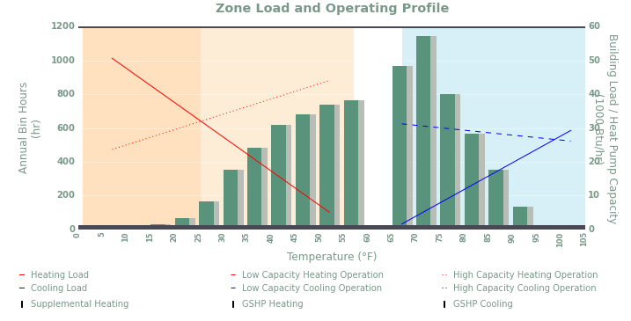

In this case, the number of bin hours below Building Balance Point temperature (the outdoor air temperature at which the heat generated inside the building balances the building's heat losses to maintain a desired indoor temperature) is of only 38 hours, which explains the low additional cost of operation due to supplemental heat. By using a PSC-030 instead of a PSC-036 we save on installation cost, without compromising the cost of operation of the system. We have therefore optimized the system mix and selected an optimal system balance between geothermal and supplemental.

If you wish to use the System Sizing Worksheets (see II.) for sizing purposes, you will need to adapt the sheet instructions if you are not sizing to 100% of the heating load.

EXAMPLE: You used the Balance Point Calculator to calculate a target Balance Point Temperature and determined that you only need to size to 84% of the heating load to achieve that.
You will need to adjust your Heating Load as well as the Heating Output (the “Design capacity” given in the performance tables) to use the worksheets
  - Design Heating Load @ 84% (BTUH) = 0.84 * Heating Load (BTUH)
  - To calculate the system heating capacity at 84%, you will need to use the performance tables. Once you know the Earth Temperature and the Loop type, read the heating Maximum Capacity and the heating Design Capacity @ 100%.
Design Capacity @ 84% (BTUH) = 0.84 * Design Capacity (100%) (BTUH) + (1 – 0.84) * Maximum Capacity (BTUH)

Design Capacity @ 84% (BTUH) ≥ Design Heating Load @ 84% (BTUH)

  - Verify that:
  - Calculate the amount of Auxiliary Heat you will be needing:
$$Minimum Auxiliary Heat \left(kW\right)= \\ \frac{Design Heating Load @ 84\% \left(BTUH\right) * 0.2}{3412}+\left(1-0.84\right)*\frac{[Heating Load \left(BTUH\right)- Design Capacity @ 84\% \left(BTUH\right)] }{3412}$$

Supplement heat to meet the rest of the heating load

Auxiliary heat to anticipate extreme weather conditions when design temperatures may be exceeded

LoopLink

In partnership with GeoConnections, Inc., EarthLinked developed the EarthLinked Geothermal Design Software, a customized version of LoopLink. This powerful web-based ground loop design tool that enables you to design loop fields for multiple zone, multiple heat pump geothermal systems faster and more accurately than ever before.
The tool can be accessed at: https://eti.looplinkrlc.com where you will be able to subscribe to a plan.
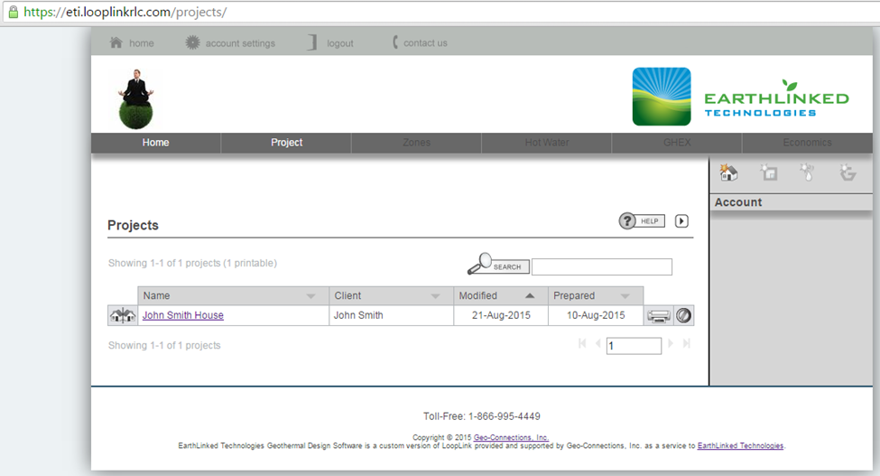
Screenshot of the LoopLink interface

Thermostat set up

    - Thermostat control

Two-stage thermostat heating control: First stage controls the compressor and second stage controls supplemental heat.
(Note: EarthLinked two-speed units don’t run at low speed in heating mode because there is no advantage to it: the unit would have to run longer at low speed to satisfy the load, increasing runtime without necessarily generating savings. The main advantage of a two-stage unit is for dehumidification purposes in cooling mode)

Two-stage thermostat cooling control: EarthLinked two-speed units come with an automatic 10-minute timer for the low speed in cooling mode, before initiating the high speed when required by the cooling load. Two-stage thermostat control is still an option for cooling: the first stage of the thermostat will simply be overridden by the timer if the compressor exceeds 10 minutes of runtime in first stage.

Based on that information, any thermostat you install has the following minimum compatibility requirement: two stages for heating and one stage for cooling.

    - Auxiliary heat set up

Supplemental heat should not be triggered by temperature differential alone.

CASE 1: Auxiliary heat controlled by outdoor sensor/balance point temperature:
In this case, you will need to purchase an outdoor thermostat (EarthLinked’s Model THOD or equivalent) to initiate supplemental heat. Use the Balance Point Calculator embedded in the System Sizing Worksheets to calculate the balance point temperature and set the outdoor thermostat (set point) to the balance point temperature.
You can access the Balance Point Calculator at earthlinked.com/dealers under the “System Sizing & Performance Tables” header in the “Technical Manuals” section. Download and open the excel file.

CASE 2: Auxiliary heat controlled by time:
Read the manufacturer's thermostat manual to correctly adjust the different settings, such as runtimes, temperature differential, set point temperatures, heating/cooling start temperatures etc.
Supplemental heat should not be triggered by the temperature differential alone, but (also) by time: a maximum unit runtime needs to be set. Exceeding this runtime will turn supplemental heat on. Keep in mind when setting this that you have to compromise between the following factors:
- System efficiency (geothermal being more efficient, delaying supplemental heat can help keep the cost operation down. However excessively long run times can increase the necessary ground recovery time)
- Comfort (shorter cycles can help maintaining appropriate comfort levels in the home)
- Dehumidification (which benefits from longer run times)
- Compressor lifespan (minimum compressor run time: 10 minutes, minimum compressor off time: 5 minutes)

System Sizing Worksheets

- The 4 sizing guides noted below cover all combinations for (1) air and hydronic heating and cooling systems, and (2) heating and cooling dominant loads.
- They are listed below and provide the procedures for correctly sizing an EarthLinked® system for a specific application.
- Each of the guides utilize information from previously and separately calculated heating and cooling loads at design temperatures (Section III), and selected system performance values (Section IV).
- Please note that compressor nominal capacities are given in kBTUH and not in Tons.

The worksheets are as follows:
A. Air Heating, 100% load 12
B. Air Cooling, 105% load 15
C. Hydronic Heating, 100% load 178
D. Hydronic Cooling, 105% load 22

Air Heating, 100% load
EarthLinked®
SYSTEM SIZING GUIDE
AIR HEATING, 100%

DOMINANT LOAD: HEATING SIZING TO: 100% OF HEATING LOAD
1/3
This worksheet applies to systems using a DX air handler or cased coil.

- Heating and Cooling Loads:
Determine heating and cooling requirements (heat gain and heat loss) of the structure, based on the ACCA Manual J (latest edition) procedure using the ASHRAE 99.6% heating design temperature and the 0.4% cooling design temperature from the EarthLinked® System Sizing and Performance Tables (SSPT - section III). Elite RHVAC or Wrightsoft Right-J software is recommended.

- Domestic water heating
If domestic water heating by Heat Recovery Module (HRM) is part of the system, for each occupant add 1,000 BTUH to the Heating Load.

Winter Design Temp: ________ °F
Heating Load: ________________ BTUH

Summer Design Temp: ________ °F
Total Cooling Load: ______________ BTUH

Sensible Cooling Load: ___________ BTUH

- Local Earth Temperature
Determine local earth temperature from Temperature Map.
Site Location: _________________
City
_____________
State/Prov.
Earth Temp: _________ °F

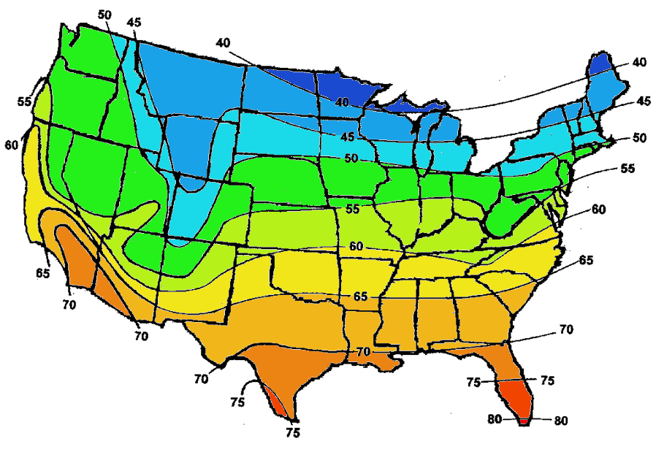
EARTH TEMPERATURES IN CONTIGUOUS UNITED STATES AND SOUTHERN CANADA

ROUND DOWN in heating

- System parameters:
2/3
Locate the System Performance Data in the Air Heating Performance Table (SSPT-section IV) based on:
- Compressor type: _______________________ (Classic Series or Prime Series)
- Earth Temperature ________ (see step 3)
(H1, V1, D1, V1.5, D1.5, V2 or D2 based upon available land area and geology of the earth at the site)
- Earth Loop Configuration ______________
- System Size and Heating Output:
- Size of the system determined by: Heating Output (Design Capacity) of the system.
Use the appropriate Air Heating Performance Table (SSPT-section IV) selected based on step 4 above.
- The initial selection of a system size (nominal capacity) should have a Heating Output of at least 100% of the Heating Load in step 2.
Supplemental heat with a rating of at least 20% of the heating load, in BTUH, is a required component of the system.
System Size Heating Output Heating Load
(nominal capacity) (Design Capacity @ 100% Load) (see Step 2)
________________ kBTUH
__________________ BTUH
_________________ BTUH

Is Heating Output at least 100% of the heating load? ☐ YES ☐ NO
Does the performance table require that the unit be equipped with an HPE? ☐ YES ☐ NO
(HPE: Heating Performance Enhancement Kit is a required component to enhance heating performance for Horizontal loops where ground temperature is 70°F or higher. It is recommended for any applications where automatic change-over or switching between heating and cooling occurs within a 24-hour period)

- Cooling Outputs:
From the appropriate Air Cooling Performance Table (SSPT-section IV) determine the Total and Sensible Cooling Outputs using:
- System parameters (see Step 4)
- System size (see Step 5)
Re-Enter the system size (see Step 5) and the Total Cooling Load and Sensible Cooling Load values (see Step 2) below:
System Size Cooling Output Cooling Loads
(nominal capacity) (Design Capacities) (see Step 2)
________________ kBTUH
TOTAL: ________________ BTUH
TOTAL: ______________ BTUH

SENSIBLE: ________________ BTUH
SENSIBLE: ______________ BTUH

Is Total Cooling Output 5% greater than Total Cooling Load? ☐ YES ☐ NO
Is Sensible Cooling Output 5% greater than Sensible Cooling Load? ☐ YES ☐ NO

Does the performance table require that the unit be equipped with an HCM? ☐ YES ☐ NO
(HCM: Hybrid Cooling Module is a required component to enhance cooling mode system efficiency and performance when required by the performance tables or for applications having low thermal conductivity soils or sustained high summer temperatures above cooling design temperature)
- Selected system:
3/3

System Size: ________________ kBTUH
Compressor Unit Model: ____________________________

Air Handler/Cased Coil Model: _______________________________
Supplemental Electric Heat Kit: ☐ 5kW ☐10kW ☐15kW ☐20kW (must be ≥ 20% heat load)
Earth Loop Model: _________________________
Domestic Water Heating: _______________________________ (Heat Recovery Module Model)
Heating Performance Enhancement Kit (HPE): _______________________________
Hybrid Cooling Module (HCM): _______________________________

- Balance Point:
The balance point temperature for a heating system must be determined if an outdoor thermostat is installed to initiate supplemental heat. The outdoor thermostat set point is adjusted to the balance point temperature.
For EarthLinked® R-410A systems two heating outputs must be known to determine balance point temperature:
- Design capacity @ 100% Load (see Step 5).
- Maximum capacity (the MAXIMUM heating capacity taken from the Air Heating Performance Table (SSPT-section IV) for the specific system selected. Row right above the “Design capacity @ 100% Load”)

To access the Balance Point Calculator:
- You can go to www.earthlinked.com/dealers. Sign in under the “EXISTING USERS LOG IN” section. The Calculator can be found under the “System Sizing & Performance Tables” header in the “Technical Manuals” section. Download and open the excel file.
- Or double-click on the image below:
DOUBLE-CLICK HERE
See step 1 and Manual J
See step 5
See step 8 above

Balance Point Capacity = ________________ BTUH
Balance Point Temperature = ___________ °F

Air Cooling, 105% load
EARTH TEMPERATURES IN CONTIGUOUS UNITED STATES AND SOUTHERN CANADA
EarthLinked®
SYSTEM SIZING GUIDE
AIR COOLING, 105%

ROUND UP in cooling

1/3
DOMINANT LOAD: COOLING SIZING TO: 105% OF COOLING LOADS
This worksheet applies to systems using a DX air handler or cased coil.

- Heating and Cooling Loads:
Determine heating and cooling requirements (heat gain and heat loss) of the structure, based on the ACCA Manual J (latest edition) procedure using the ASHRAE 99.6% heating design temperature and the 0.4% cooling design temperature from the EarthLinked® System Sizing and Performance Tables (SSPT - section III). Elite RHVAC or Wrightsoft Right-J software is recommended.

- Domestic water heating
If domestic water heating by Heat Recovery Module (HRM) is part of the system, for each occupant add 1,000 BTUH to the Heating Load.

Summer Design Temp: ________ °F
Total Cooling Load: _______________ BTUH

Sensible Cooling Load: ______________ BTUH

Winter Design Temp: ________ °F
Heating Load: ______________ BTUH

- Local Earth Temperature
Determine local earth temperature from Temperature Map.
Site Location: _________________
City
_______________
State/Prov.
Earth Temp: _________ °F

- System parameters:
2/3
Locate the System Performance Data in the Air Cooling Performance Table (SSPT-section IV) based on:
- Compressor type: _______________________ (Classic Series or Prime Series)
- Earth Temperature ________ (see step 3)
- Earth Loop Configuration ______________
(H1, V1, D1, V1.5, D1.5, V2 or D2 based upon available land area and geology of the earth at the site)
- System Size and Cooling Output:
- Size of the system determined by: Total Cooling Output and Sensible Cooling Output
Use the appropriate Air Cooling Performance Table (SSPT-section IV) selected based on step 4 above.
- The initial selection of a system size (nominal capacity) should have a Total and Sensible Cooling outputs of at least 105% of the Total and Sensible Cooling Loads respectively.

System Size Cooling Output Cooling Loads
(nominal capacity) (Design Capacities) (see Step 2)
________________ kBTUH
TOTAL: ________________ BTUH
TOTAL: ________________ BTUH

SENSIBLE: ________________ BTUH
SENSIBLE: ______________ BTUH

Is Total Cooling Output 5% greater than Total Cooling Load? ☐ YES ☐ NO
Is Sensible Cooling Output 5% greater than Sensible Cooling Load? ☐ YES ☐ NO

Does the performance table require that the unit be equipped with an HCM? ☐ YES ☐ NO
(HCM: Hybrid Cooling Module is a required component to enhance cooling mode system efficiency and performance when required by the performance tables or for applications having low thermal conductivity soils or sustained high summer temperatures above cooling design temperature)

- Heating Output:
From the appropriate Air Heating Performance Table (SSPT-section IV) determine the Heating Output using:
- System parameters (see Step 4)
- System size (see Step 5)
Supplemental heat with a rating of at least 20% of the heating load, in BTUH, is a required component of the system.
Re-Enter the system size (see Step 5) and the Heating Load value (see Step 2) below:
System Size Heating Output Heating Load
(nominal capacity) (Design Capacity @ 100% Load) (see Step 2)
________________ kBTUH
__________________ BTUH
_________________ BTUH

Is Heating Output at least 100% of the heating load? ☐ YES ☐ NO
Does the performance table require that the unit be equipped with an HPE? ☐ YES ☐ NO
(HPE: Heating Performance Enhancement Kit is a required component to enhance heating performance for Horizontal loops where ground temperature is 70°F or higher. It is recommended for any applications where automatic change-over or switching between heating and cooling occurs within a 24-hour period)

- Selected system:
3/3

System Size: ________________ kBTUH
Compressor Unit Model: ____________________________

Air Handler/Cased Coil Model: _______________________________
Supplemental Electric Heat Kit: ☐ 5kW ☐10kW ☐15kW ☐20kW (must be ≥ 20% heat load)
Earth Loop Model: _________________________
Domestic Water Heating: _______________________________ (Heat Recovery Module Model)
Heating Performance Enhancement Kit (HPE): _______________________________
Hybrid Cooling Module (HCM): _______________________________

- Balance Point:
The balance point temperature for a heating system must be determined if an outdoor thermostat is installed to initiate supplemental heat. The outdoor thermostat set point is adjusted to the balance point temperature.
For EarthLinked® R-410A systems two heating outputs must be known to determine balance point temperature:
- Design capacity @ 100% Load (see Step 6).
- Maximum capacity (the MAXIMUM heating capacity taken from the Air Heating Performance Table (SSPT-section IV) for the specific system selected. Row right above the “Design capacity @ 100% Load”)

To access the Balance Point Calculator:
- You can go to www.earthlinked.com/dealers. Sign in under the “EXISTING USERS LOG IN” section. The Calculator can be found under the “System Sizing & Performance Tables” header in the “Technical Manuals” section. Download and open the excel file.
- Or double-click on the image below:
DOUBLE-CLICK HERE
See step 1 and Manual J
See step 6
See step 8 above
Balance Point Capacity = ________________ BTUH
Balance Point Temperature = ___________ °F

Hydronic Heating, 100% load
EARTH TEMPERATURES IN CONTIGUOUS UNITED STATES AND SOUTHERN CANADA
EarthLinked®
SYSTEM SIZING GUIDE
HYDRONIC HEATING, 100%

1/4
DOMINANT LOAD: HEATING SIZING TO: 100% OF HEATING LOAD
This worksheet applies to radiant panel hydronic systems using a hydronic water module (HWM) or a compressor equipped with an internal refrigerant to water heat exchanger.

- Heating and Cooling Loads:
Determine heating and cooling requirements (heat gain and heat loss) of the structure, based on the ACCA Manual J (latest edition) procedure using the ASHRAE 99.6% heating design temperature and the 0.4% cooling design temperature from the EarthLinked® System Sizing and Performance Tables (SSPT-section III). Elite RHVAC or Wrightsoft Right-J software is recommended.

- Domestic water heating
If domestic water heating by Heat Recovery Module (HRM) is part of the system, add 1,000 BTUH for each adult and teenager to the Heating Load.

Winter Design Temp: ________ °F
Heating Load: ________________ BTUH

Summer Design Temp: ________ °F
Total Cooling Load: ______________ BTUH

- Local Earth Temperature: determine local earth temperature from Temperature Map.
Site Location: _________________
City
_______________
State/Prov.
Earth Temp: _________ °F

ROUND DOWN in heating

- System parameters:
2/4
Locate the System Performance in the Hydronic Heating Performance Table (SSPT-section IV) based on:
- Compressor type: _______________________ (Classic Series or Prime Series)
- Earth Temperature ________ (see step 3)
(H1, V1, D1, V1.5, D1.5, V2 or D2 based upon available land area and geology of the earth at the site)
- Earth Loop Configuration ______________

- System Size and Adjusted Heating Output:
- Size of the system determined by: Adjusted Heating Output of the system.
Use the appropriate Hydronic Heating Performance Table (SSPT-section IV) selected based on step 4 above.
- The initial selection of a system size (nominal capacity) should have an Adjusted Heating Output of at least 100% of the Heating Load in step 2.
Supplemental heat with a rating of at least 20% of the heating load, in BTUH, is a required component of the storage water heater.
Start by adjusting the Heating Output (Design Capacity @ 100% Load) by multiplying it by the appropriate correction factor below. The correction factor is based on the desired Leaving Water Temperature (as measured at the outlet of the heat exchanger).

CORRECTION FACTORS
HYDRONIC HEATING ONLY
Leaving Water  Temperatures (°F) | CORRECTION FACTORS  (Capacity & COP)
80 | 1.17
90 | 1.09
100 | 1.00
110 | 0.90

Adjusted Heating Output = Heating Output (Design Capacity @ 100% load) X Correction factor
= ______________________________ BTUH X ______________
= __________________ BTUH

System Size Adjusted Heating Output Heating Load
(nominal capacity) (see above) (see Step 2)
________________ kBTUH
__________________ BTUH
_________________ BTUH

Is Adjusted Heating Output at least 100% of the heating load? ☐ YES ☐ NO
Does the performance table require that the unit be equipped with an HPE? ☐ YES ☐ NO
(HPE: Heating Performance Enhancement Kit is a required component to enhance heating performance for Horizontal loops where ground temperature is 70°F or higher. It is recommended for any applications where automatic change-over or switching between heating and cooling occurs within a 24-hour period)

- Cooling Output:
3/4
For a chilled water air handler: from the appropriate Hydronic Cooling Performance Table (SSPT-section IV) determine the Total Cooling Output using:
- System parameters (see Step 4)
- System size (see Step 5)
You should adjust the Total Cooling Output (Design Total Capacity) by multiplying it by the appropriate correction factor below. The correction factor is based on the desired Leaving Water Temperature (as measured at the outlet of the heat exchanger).

CORRECTION FACTORS
HYDRONIC COOLING ONLY
Leaving Water  Temperatures (°F) | CORRECTION FACTORS  (Capacity & EER)
42 | 0.94
45 | 1.00
48 | 1.06
52 | 1.15
56 | 1.24
60 | 1.33

Adjusted Cooling Output
= Cooling Output (Design Total Capacity) X Correction factor
= ___________________________ BTUH X ______________
= __________________ BTUH

\
.

Re-Enter the system size (see Step 5) and the Total Cooling Load value (see Step 2) below:
System Size Adjusted Cooling Output Cooling Load
(nominal capacity) (see above) (see Step 2)
________________ kBTUH
TOTAL: ________________ BTUH
TOTAL: ________________ BTUH
Is Adjusted Total Cooling Output 5% greater than Total Cooling Load? ☐ YES ☐ NO

Does the performance table require that the unit be equipped with an HCM? ☐ YES ☐ NO
(HCM: Hybrid Cooling Module is a required component to enhance cooling mode system efficiency and performance when required by the performance tables or for applications having low thermal conductivity soils or sustained high summer temperatures above cooling design temperature)

- Selected system:

System Size: ________________ kBTUH
Compressor Unit Model: ____________________________

Hydronic Water Module Model: _______________________________
Supplemental Electric Heat Kit: ☐ 5kW ☐10kW ☐15kW ☐20kW (must be ≥ 20% heat load)
Earth Loop Model: _________________________
Domestic Water Heating: _______________________________ (Heat Recovery Module Model)
Heating Performance Enhancement Kit (HPE): _______________________________
Hybrid Cooling Module (HCM): _______________________________

- Balance Point:
4/4
The balance point temperature for a heating system must be determined if an outdoor thermostat is installed to initiate supplemental heat. The outdoor thermostat set point is adjusted to the balance point temperature.
For EarthLinked® R-410A systems two heating outputs must be known to determine balance point temperature:
- Adjusted Heating Output (see Step 5).
- Maximum capacity (the MAXIMUM heating capacity taken from the Hydronic Heating Performance Table (SSPT-section IV) for the specific system selected. Row right above the “Design capacity @ 100% Load”)

To access the Balance Point Calculator:
- You can go to www.earthlinked.com/dealers. Sign in under the “EXISTING USERS LOG IN” section. The Calculator can be found under the “System Sizing & Performance Tables” header in the “Technical Manuals” section. Download and open the excel file.
- Or double-click on the image below:
DOUBLE-CLICK HERE
See step 1 and Manual J
See step 5
See step 8 above

Balance Point Capacity = ________________ BTUH
Balance Point Temperature = ___________ °F

Hydronic Cooling, 105% load
EarthLinked®
SYSTEM SIZING GUIDE
HYDRONIC COOLING, 105%

EARTH TEMPERATURES IN CONTIGUOUS UNITED STATES AND SOUTHERN CANADA

DOMINANT LOAD: COOLING SIZING TO: 105% OF COOLING LOAD
This worksheet applies to radiant panel hydronic systems using a hydronic water module (HWM) or a compressor equipped with an internal refrigerant to water heat exchanger.

- Heating and Cooling Loads:
Determine heating and cooling requirements (heat gain and heat loss) of the structure, based on the ACCA Manual J (latest edition) procedure using the ASHRAE 99.6% heating design temperature and the 0.4% cooling design temperature from the EarthLinked® System Sizing and Performance Tables (SSPT-section III). Elite RHVAC or Wrightsoft Right-J software is recommended.

- Domestic water heating
If domestic water heating by Heat Recovery Module (HRM) is part of the system, add 1,000 BTUH for each adult and teenager to the Heating Load.

Summer Design Temp: ________ °F
Total Cooling Load: ______________ BTUH

Winter Design Temp: ________ °F
Heating Load: ________________ BTUH

- Local Earth Temperature: determine local earth temperature from Temperature Map.
Site Location: _________________
_______________
Earth Temp: _________ °F

City
State/Prov.

ROUND UP in cooling

- System parameters:
2/4
Locate the System Performance in the Hydronic Cooling Performance Table (SSPT-section IV) based on:
- Compressor type: _______________________ (Classic Series or Prime Series)
- Earth Temperature ________ (see step 3)
(H1, V1, D1, V1.5, D1.5, V2 or D2 based upon available land area and geology of the earth at the site)
- Earth Loop Configuration ______________

- System Size and adjusted Cooling Output:
- Size of the system determined by: Adjusted Cooling Output of the system.
Use the appropriate Hydronic Cooling Performance Table (SSPT-section IV) selected based on step 4 above.
- The initial selection of a system size (nominal capacity) should have an Adjusted Cooling Output of at least 105% of the Cooling Load in step 2.

Start by adjusting the Cooling Output (Design Total Capacity) by multiplying it by the appropriate correction factor below. The correction factor is based on the desired Leaving Water Temperature (as measured at the outlet of the heat exchanger).

CORRECTION FACTORS
HYDRONIC COOLING ONLY
Leaving Water  Temperatures (°F) | CORRECTION FACTORS  (Capacity & EER)
42 | 0.94
45 | 1.00
48 | 1.06
52 | 1.15
56 | 1.24
60 | 1.33

Adjusted Cooling Output
= Cooling Output (Design Total Capacity) X Correction factor
= _______________________ BTUH X ______________
= __________________ BTUH

System Size Adjusted Cooling Output Cooling Load
(nominal capacity) (see above) (see Step 2)
________________ kBTUH
TOTAL: ________________ BTUH
TOTAL: ________________ BTUH

Is Adjusted Total Cooling Output 5% greater than Total Cooling Load? ☐ YES ☐ NO

Does the performance table require that the unit be equipped with an HCM? ☐ YES ☐ NO
(HCM: Hybrid Cooling Module is a required component to enhance cooling mode system efficiency and performance when required by the performance tables or for applications having low thermal conductivity soils or sustained high summer temperatures above cooling design temperature)

- Heating Output:
3/4
If Hydronic Heating is also required, from the appropriate Hydronic Heating Performance Table (SSPT-section IV) determine the Heating Output using:
- System parameters (see Step 4)
- System size (see Step 5)
Supplemental heat with a rating of at least 20% of the heating load, in BTUH, is a required component of the storage water heater.
You should adjust the Heating Output (Design Capacity @ 100% Load) by multiplying it by the appropriate correction factor below. The correction factor is based on the desired Leaving Water Temperature (as measured at the outlet of the heat exchanger).

CORRECTION FACTORS
HYDRONIC HEATING ONLY
Leaving Water  Temperatures (°F) | CORRECTION FACTORS  (Capacity & COP)
80 | 1.17
90 | 1.09
100 | 1.00
110 | 0.90

Adjusted Heating Output
= Heating Output (Design Capacity) X Correction factor
= ____________________ BTUH X ______________
= __________________ BTUH

Re-Enter the system size (see Step 5) and the Heating Load (see Step 2) below:
System Size Adjusted Heating Output Heating Load
(nominal capacity) (see above) (see Step 2)
________________ kBTUH
__________________ BTUH
_________________ BTUH

Is Adjusted Heating Output at least 100% of the heating load? ☐ YES ☐ NO
Does the performance table require that the unit be equipped with an HPE? ☐ YES ☐ NO
(HPE: Heating Performance Enhancement Kit is a required component to enhance heating performance for Horizontal loops where ground temperature is 70°F or higher. It is recommended for any applications where automatic change-over or switching between heating and cooling occurs within a 24-hour period)

- Selected system:

System Size: ________________ kBTUH
Compressor Unit Model: ____________________________

Hydronic Water Module Model: _______________________________
Supplemental Electric Heat Kit: ☐ 5kW ☐10kW ☐15kW ☐20kW (must be ≥ 20% heat load)
Earth Loop Model: _________________________
Domestic Water Heating: _______________________________ (Heat Recovery Module Model)
Heating Performance Enhancement Kit (HPE): _______________________________
Hybrid Cooling Module (HCM): _______________________________

- Balance Point:
4/4
The balance point temperature for a heating system must be determined if an outdoor thermostat is installed to initiate supplemental heat. The outdoor thermostat set point is adjusted to the balance point temperature.
For EarthLinked® R-410A systems two heating outputs must be known to determine balance point temperature:
- Adjusted Heating Output (see Step 6).
- Maximum capacity (the MAXIMUM heating capacity taken from the Hydronic Heating Performance Table (SSPT-section IV) for the specific system selected. Row right above the “Design capacity @ 100% Load”)

To access the Balance Point Calculator:
- You can go to www.earthlinked.com/dealers. Sign in under the “EXISTING USERS LOG IN” section. The Calculator can be found under the “System Sizing & Performance Tables” header in the “Technical Manuals” section. Download and open the excel file.
- Or double-click on the image below:
DOUBLE-CLICK HERE
See step 1 and Manual J
See step 6
See step 8 above

Balance Point Capacity = ________________ BTUH
Balance Point Temperature = ___________ °F

Design Temperatures

ASHRAE Outdoor Design Condition

Heating and cooling design temperatures for selected locations in the U.S.A. and Canada are listed on the following pages. This table is from the 2009 ASHRAE Handbook of Fundamentals, Chapter 14, Climatic Design Information – Appendix, with permission from ASHRAE.
The values for heating design temperatures represent 99.6% of the recorded temperatures during the heating season for the selected location. The values for cooling design temperatures represent all but 0.4% of the recorded temperatures during the cooling season for the selected location.
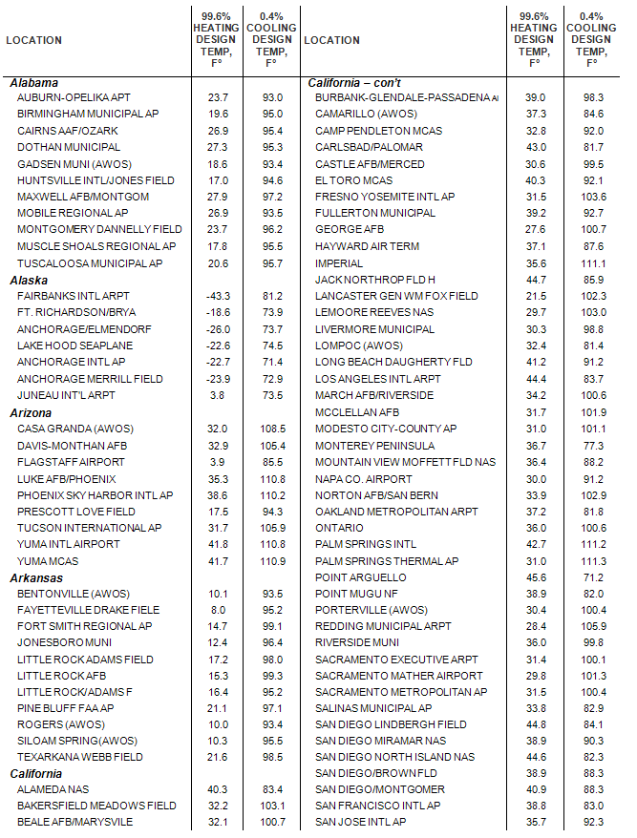
ASHRAE Design Temperatures for Selected Locations 1/8

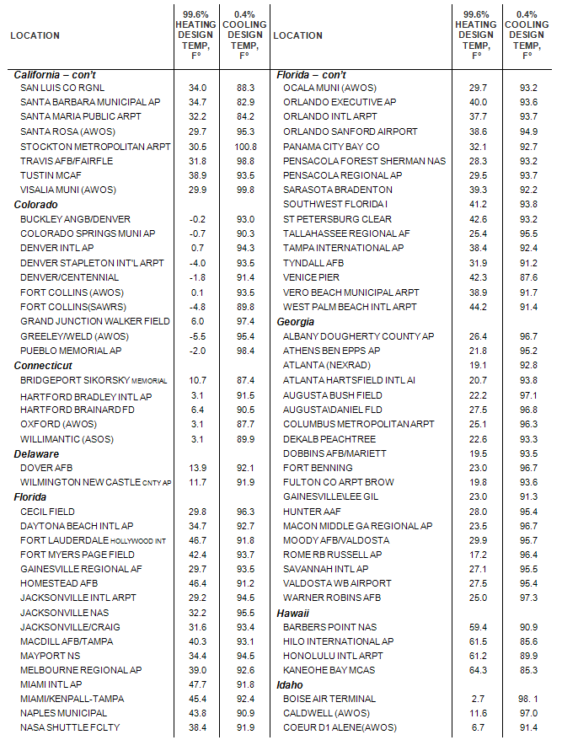
ASHRAE Design Temperatures for Selected Locations 2/8

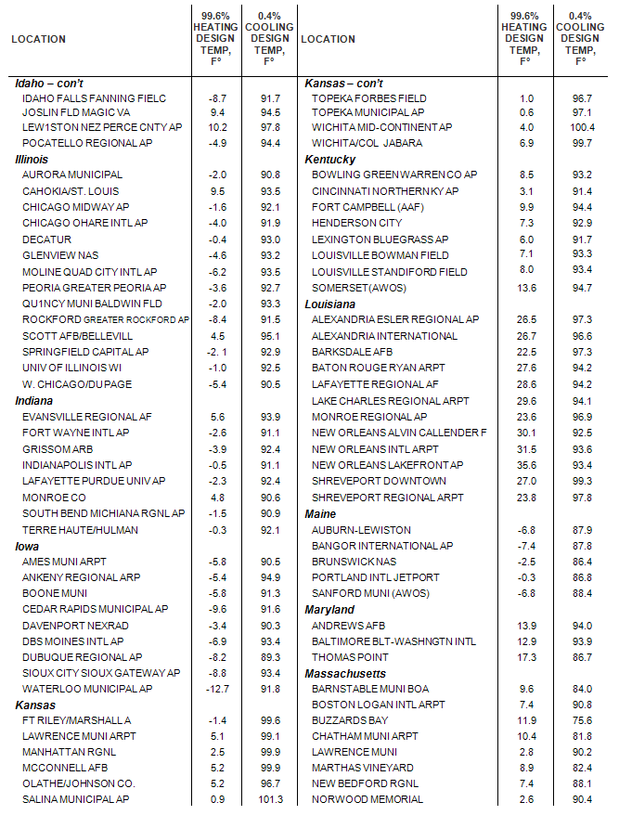
ASHRAE Design Temperatures for Selected Locations 3/8

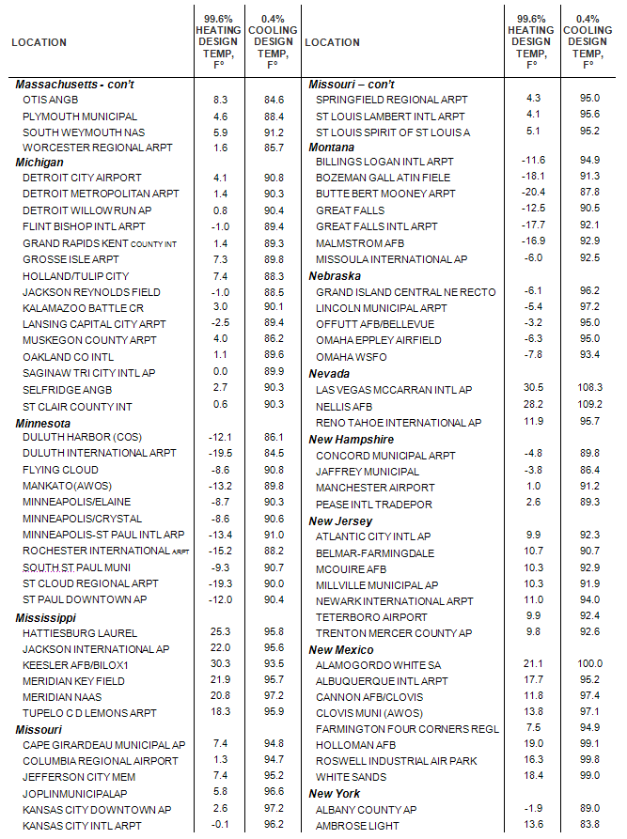
ASHRAE Design Temperatures for Selected Locations 4/8
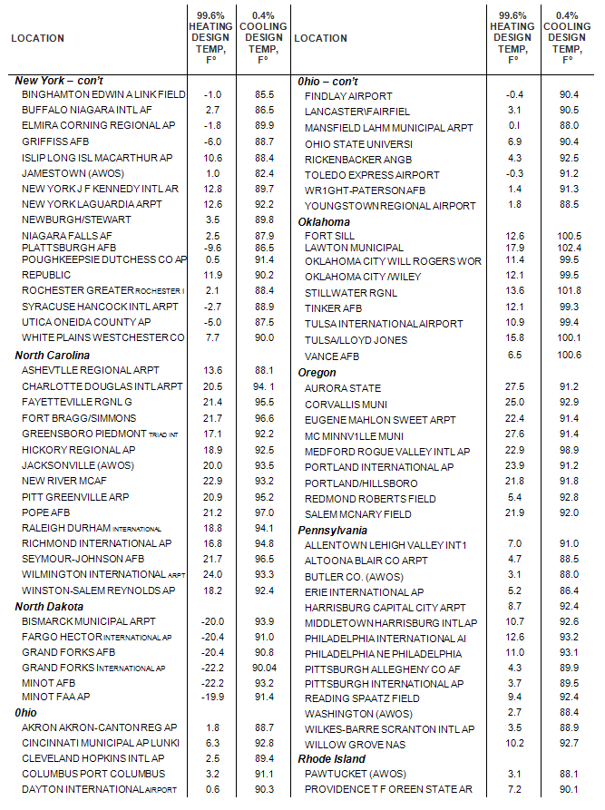
ASHRAE Design Temperatures for Selected Locations 5/8
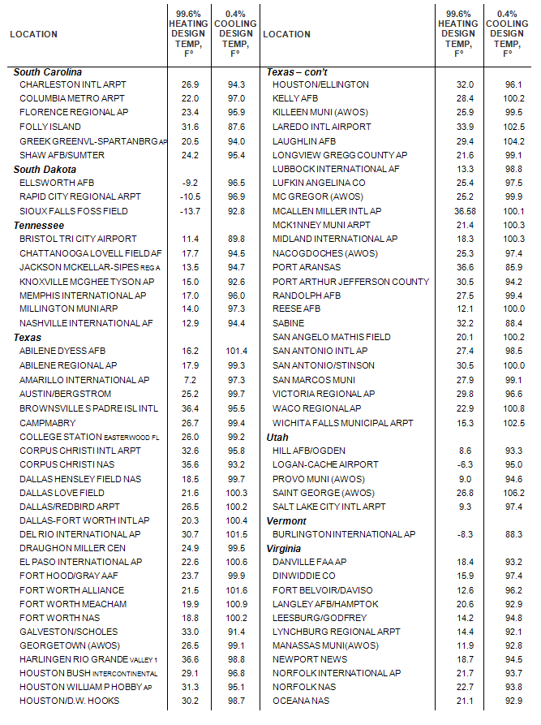
ASHRAE Design Temperatures for Selected Locations 6/8
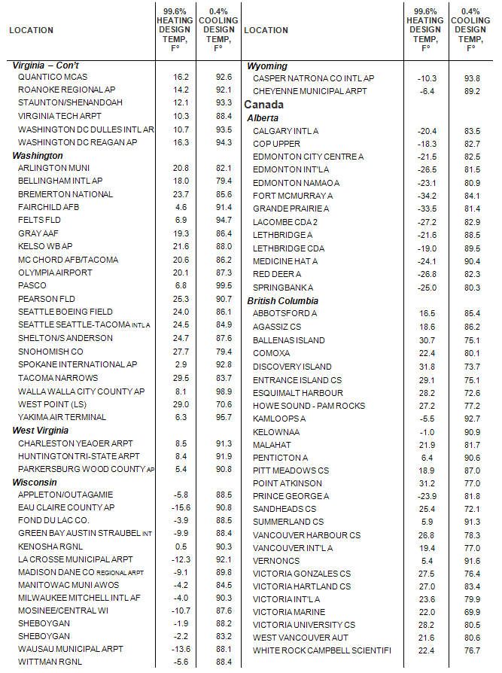
ASHRAE Design Temperatures for Selected Locations 7/8
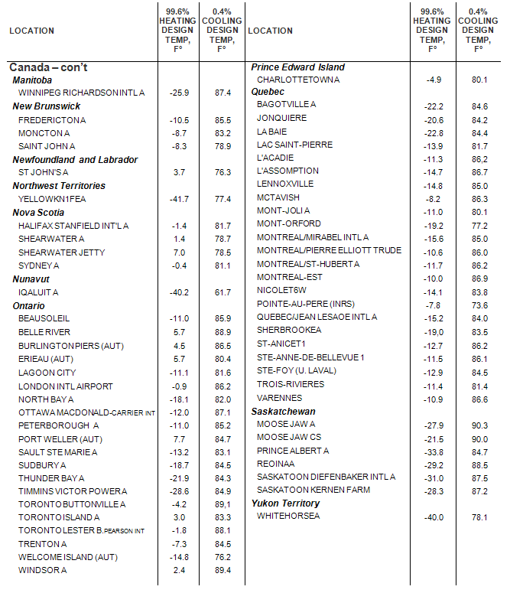
ASHRAE Design Temperatures for Selected Locations 8/8

Performance Tables

Introduction
PUTTING PERFORMANCE TABLES IN THEIR PROPER PERSPECTIVE
Compressor unit and air handler system performance tables are based upon data from the performance of ETI-specified compressor units and air handlers that are components of systems that are properly sized and installed, and have earth loops located in soil that has average thermal conductivity for their region. The tables describe only the performance of ETI-specified compressor units and air handlers within the range of normal operating conditions.
The performance, comfort and economy afforded by an EarthLinked® System is dependent upon the proper sizing and selection, installation and maintenance of the entire system for the specific application and location. The complete system may include the compressor unit, earth loops, air handler and ducting (or refrigerant-to-water heat exchanger, water tank, pumps and water piping., for a hydronic system) and thermostat.
A detailed, documented heating and cooling load calculation must be accurately completed in accordance with the ACCA Manual J (latest edition), and utilized with the appropriate ASHRAE design temperatures listed in this manual for the location of the installation. It is imperative that the equipment is sized in accordance with the procedures in this manual.
Failure to perform correct heating and cooling load calculations or to properly select and install the appropriate system size and other components for the project will affect system performance and will void the application of the warranty. The heating and cooling system operation habits of the building occupants (such as adjusting the thermostat beyond the temperature range for which the specific installation was designed, etc.) may also negatively affect system performance.

Tutorial
The complete performance tables can be found in IV.3) in the form of an Excel file. Simply double-click on the file icon and the Microsoft Excel file will open. Here are a few tips to easily use the file:
- View: once opened, you will see the following:

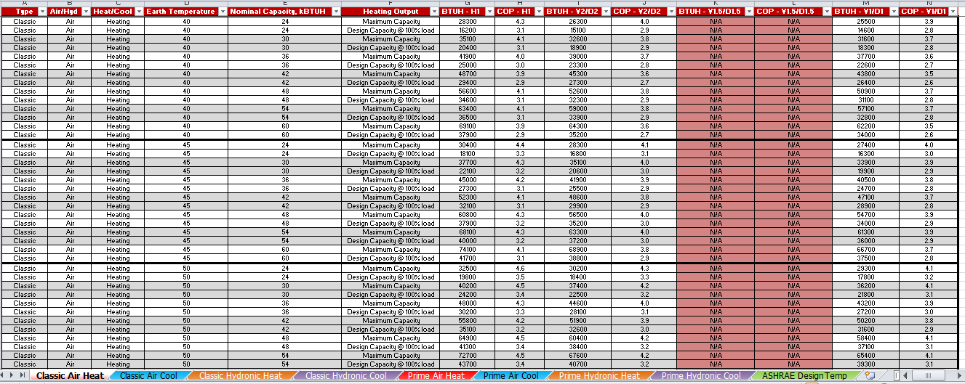
  - Bottom tabs: At the bottom you will see 9 tabs: 8 correspond to the different performance tables (with all combinations of (1) Air and Hydronic, (2) Heating and Cooling and (3) Classic and Prime Series). The last one “ASHRAE Design Temp” lists the ASHRAE Outdoor Design Condition that you can also find in section III (enabling you to search the page to quickly find a specific location).
  - Column Headers: There are 14 Column Headers. The 6 first specify the type of system (Product Series, Application, Mode, nominal capacity) and the condition (Earth Temperature, Output type). The remaining 8 columns list the performance – Capacities (BTUH) and Efficiencies (COP and EER) – for each loop type. You can click on the arrow at the bottom left of the header to filter the data shown:
Example 1: Selecting only the performances of 48 kBTUH (nominal capacity) units.
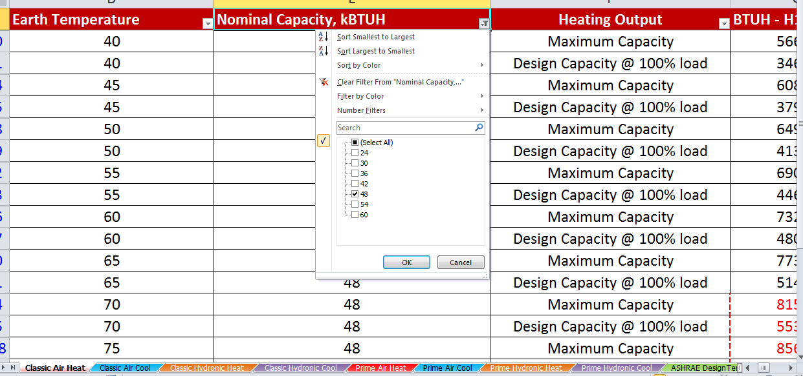
Example 2: Selecting only the performances in 50°F degree Earth.

Example 3: Selecting only the Design capacities when sizing a unit.

Complete Performance Tables

Please note that compressor nominal capacities are given in kBTUH and not in Tons.

DOUBLE-CLICK HERE

